https://www.upgrad.com/blog/cyber-security-research-topics/
Cyber security research topics focus on identifying new threats and developing advanced defense techniques to protect digital systems. With cyber attacks like ransomware and phishing constantly evolving, expertise in programming languages is essential for creating effective security tools and solutions. Staying updated on these topics is crucial to safeguard today’s interconnected world.
This blog explores the most important cyber security research topics for 2025, covering areas such as threat detection, encryption, and ethical hacking. It also highlights how programming languages play a key role in advancing cybersecurity innovation and practical defense strategies.
Ready to elevate your tech career? Dive into our Online Software Development Courses and gain the skills to build secure, scalable applications that stand strong in today’s cybersecurity landscape.
180 Trending Cybersecurity Research Topics in 2025
Cybersecurity research is a critical field that focuses on identifying vulnerabilities within digital systems and infrastructures. By analyzing these weaknesses, researchers develop effective defense mechanisms to prevent unauthorized access, data breaches, and cyber-attacks.
Accelerate your career with advanced programs in User Experience Design, AI Full Stack Development, and Cloud Computing & DevOps. Gain industry-relevant skills, hands-on experience, and certification to lead innovation and drive impact in the digital age.
This research is essential in understanding the constantly evolving landscape of cybersecurity threats, such as new malware, social engineering tactics, and sophisticated hacking methods.
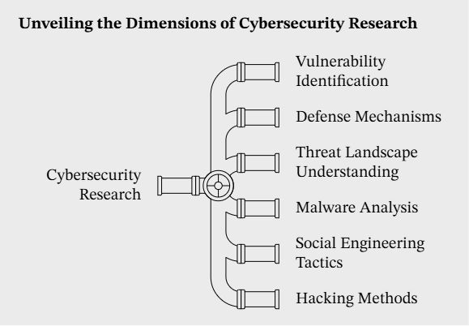



Now that you have an overview of the field let's dive deeper into the latest trends in cybersecurity research for 2025.
Research Tactics and Testing Strategies:
In cybersecurity research, computer science tactics are essential. Researchers gather data through empirical methods and conduct simulations to predict potential attack scenarios.
These efforts help identify system vulnerabilities and develop stronger defense mechanisms. Common strategies include:
- Penetration Testing: Simulating attacks to uncover weak points in a system.
- Code Review: Inspecting software code to identify potential security flaws.
- Vulnerability Scanning: Regularly scanning systems for known security issues.
As a cybersecurity professional, staying ahead of research trends is crucial. In the next section, let’s see why these topics are so important for your career development.
Importance for Cybersecurity Professionals:
For cybersecurity professionals, staying informed on emerging research topics is essential to enhance defense strategies and improve response plans. This knowledge enables professionals to:
- Anticipate Future Threats: By understanding the latest research, they can predict and prepare for evolving risks, such as AI-powered attacks or vulnerabilities in new technologies like 5G.
- Patch Vulnerabilities: Research helps identify previously unnoticed vulnerabilities, enabling timely updates and minimizing exposure to threats.
- Drive Innovation: Insights from current research lead to the development of advanced tools and methodologies, such as AI-driven threat detection, to strengthen security measures.
Let’s now see how cybersecurity research is rapidly evolving to address emerging challenges and technologies.
Evolving Nature of Cybersecurity Research:
Cybersecurity research is always evolving, responding to new technologies and sophisticated threats. As systems become more interconnected, vulnerabilities multiply, requiring ongoing adaptation.
Research continuously explores emerging areas such as:
- Artificial Intelligence: Using AI to predict and counteract attacks.
- Blockchain: Using decentralized solutions to strengthen security.
- Quantum Computing: Preparing for the potential impact of quantum breakthroughs on encryption.
Want to sharpen your skills in cybersecurity and master the latest defense techniques? upGrad’s comprehensive software engineering courses are a great way to start!
This evolving approach ensures cybersecurity stays relevant and proactive, safeguarding against ever-changing risks. Let’s now take a closer look at the top cyber security research topics currently trending in the industry.
Trending Cybersecurity Research Topics
Cybersecurity research constantly evolves to tackle new threats and vulnerabilities. As digital infrastructures become more complex, the focus shifts to developing advanced security technologies.
Researchers work on identifying weaknesses and strengthening systems against malicious actors. This research aims to address current cybersecurity challenges while preparing for future threats.
Challenges, Risks, and Threats
- Cybersecurity professionals face a growing array of cyber threats, including data breaches, malware, advanced persistent threats (APTs), and phishing attacks.
- The rise of remote work, IoT devices, and cloud computing expands the attack surface, creating more entry points for cybercriminals.
For example, remote work increases the risk of unsecured home networks, while IoT devices often lack robust security, and cloud computing introduces data vulnerability across distributed environments.
- As technology advances, cybercriminals develop increasingly sophisticated methods, requiring continuous innovation in cybersecurity research to stay ahead of emerging risks.
Research Focus
- Cybersecurity research aims to develop new techniques and technologies to protect data, systems, and networks.
- The focus is on creating robust defense mechanisms to address threats like advanced malware, ransomware, and phishing attacks.
- Research also explores integrating technologies like AI, blockchain, and quantum cryptography to enhance security infrastructures and prevent cyber threats.
Industry Response
- The industry is increasingly adopting AI-driven security tools, blockchain for data integrity, and zero-trust architectures to address cybersecurity challenges.
- These strategies aim to improve real-time threat detection, secure data management, and restrict access to sensitive information.
- As threats grow more sophisticated, the industry focuses on developing more resilient, adaptive defense measures.
Example
- A notable industry response is the increased adoption of endpoint detection and response (EDR) solutions designed to detect, investigate, and respond to attacks like ransomware.
- Researchers are also focusing on privacy concerns as the volume of personal and sensitive data online increases, aiming to ensure compliance with privacy regulations and protect against unauthorized access.
Let us have a closer look at various domains under cyber security and the various possible research topics that are available for each of them:
Innovative Mobile Security Research Topics
Mobile security has become a significant area of focus due to the widespread use of smartphones and mobile devices in everyday life. The research in this field looks at securing apps, communications, and personal data while addressing the unique challenges posed by mobile platforms.
Read the statements below and decide whether they are True or False according to the text.
- Cybersecurity research mainly focuses on marketing and product design.
- Ransomware and phishing are examples of evolving cyber threats.
- Programming languages are not necessary for developing security tools.
- Encryption and ethical hacking are important areas of cybersecurity research in 2025.
- Penetration testing involves simulating real attacks to find system vulnerabilities.
- Cybersecurity professionals don’t need to keep up with research trends.
- AI is being used in cybersecurity to predict and counteract attacks.
- Blockchain and quantum computing are not considered in current cybersecurity research.
- The increasing use of IoT and remote work has reduced cybersecurity risks.
- Endpoint Detection and Response (EDR) solutions help detect and respond to attacks like ransomware.
- Cybersecurity research explores how to secure mobile apps and personal data.
- The cybersecurity industry is moving toward a “zero-trust” approach to limit access to sensitive data.

